**Experiment Name :** Double Sideband Suppressed Carrier AM Generation

**Objective** **:** AM DSB modulation of audio signal using 455 kHz oscillator

**Required Instruments :**

1. IT-4101 Trainer Board
2. 2 mm Patch Cords 3.
3. Oscilloscope

**Theory :**

In telecommunications, modulation is the process of conveying a message signal, for example, a digital bit stream or an analog audio signal, inside another signal that can be physically transmitted. In radio communications, cable TV systems, or the public switched telephone network, electrical signals can only be transferred over a limited passband frequency spectrum, with specific (non-zero) lower and upper cutoff frequencies. The primary motivation for modulation is to facilitate the transmission of the message signal over a communication channel with a prescribed passband. When the message or information-bearing signal is of an analog kind, we speak of analog modulation or continuous wave modulation. A commonly used carrier is a sine wave, the source of which is physically independent of the source of the information-bearing signal. Modulation is done by varying the amplitude or angle of the sinusoidal carrier wave. On this basis, we can classify analog modulation into two broadly defined families: amplitude modulation and angle modulation. In amplitude modulation (AM), the amplitude of the carrier is varied according to the information-bearing signal, as the name suggests. As the information signal increases in amplitude, the carrier wave is also made to increase the amplitude. Likewise, as the information signal decreases, then the carrier amplitude decreases.

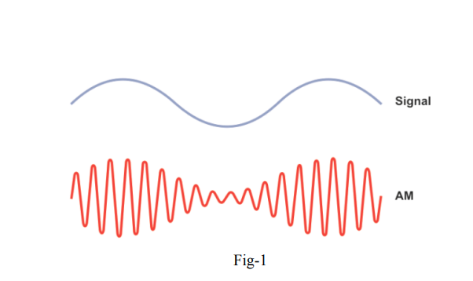

In Fig-1, we can see that the modulated carrier wave appears to ‘contain’ the information in its amplitude in some way. The types of amplitude modulation (AM):

● Double-sideband with carrier (DSB-WC)

● Double-sideband suppressed carrier (DSB-SC)

● Single-sideband (SSB)

**Procedure :**

1. Turn on the power of the IT-4101 module.
2. Make the Interface Selector Switch in the Audio Generator Output position.
3. Connect the oscilloscope probe to Audio O/P (TP3) and examine the low-frequency audio waveform. This audio frequency is a sine wave, which will be used as the modulating signal. The modulating frequency and amplitude can be varied by adjusting the Audio Generator’s Amplitude and Frequency preset. Set the amplitude and frequency to any convenient value. You can also listen to the audio signal by connecting the Audio O/P (TP3) with the Audio Amplifier I/P (TP20) and turning the Speaker ON. You can vary the volume by adjusting the Audio Amplifier Gain Adj.
4. Connect 455 kHz Local Oscillator O/P (TP5) with the Balanced Modulator-1 Carrier I/P (TP8). The local oscillator block generates the high-frequency carrier for the modulation process. The frequency is fixed at 455 kHz
5. Now connect the Audio O/P (TP3) with the Balanced Modulator-1 Audio I/P (TP7). The setup of the experiment should look like below:

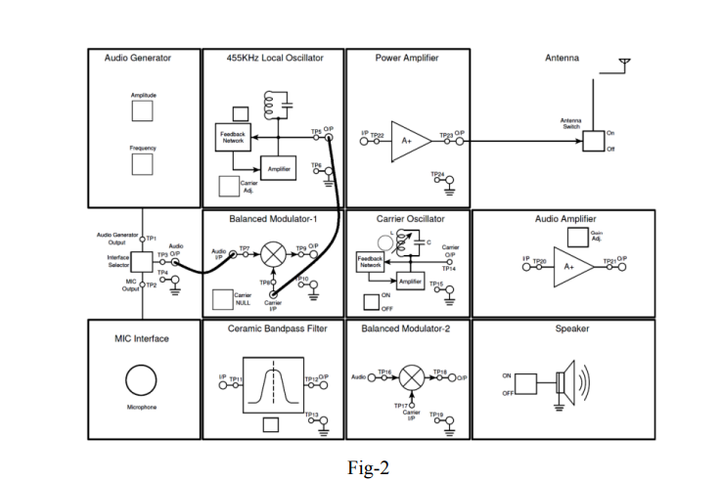

1. Connect the oscilloscope probe with Balanced Modulator-1 O/P (TP9) to observe the amplitude modulation. Adjust the Carrier NULL potentiometer to the center position until the waveform looks like this:

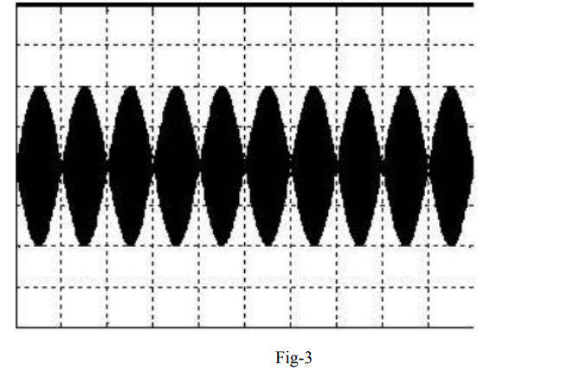

The output is a double sideband suppressed carrier AM waveform, which has been formed by amplitude modulating the 455 kHz carrier sine wave with the audio-frequency sine wave from the Audio Oscillator. Ideally, the frequency spectrum of this DSB-SC waveform should look like this:

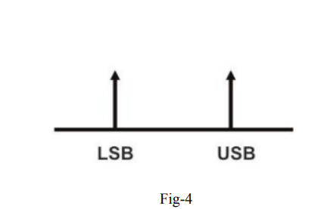

As we can see from Fig, the carrier component is absent in the DSB-SC modulated signal. Below are the modulated wave (yellow) and its frequency spectrum (purple) seen on the digital oscilloscope. Here, we can see two sideband frequency peaks around the carrier frequency of 455 kHz

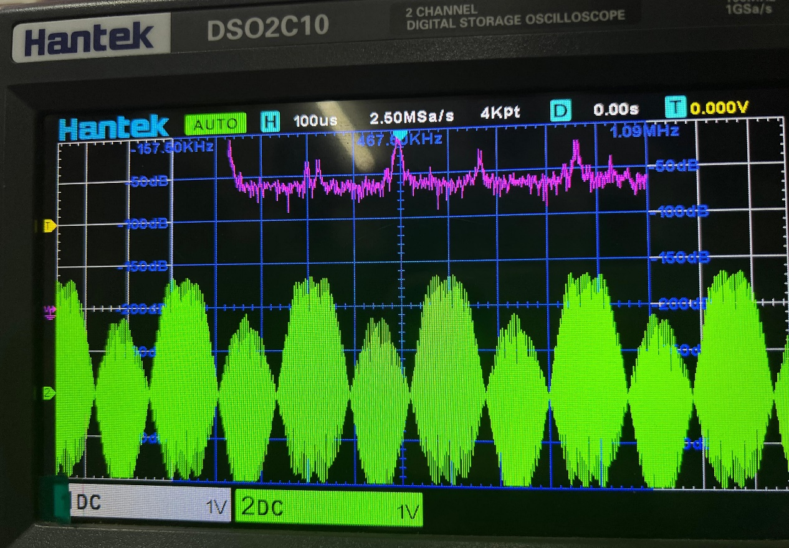

**Fig : 04**

7.Examine the Audio Output (TP3) (green) together with the modulated waveform (yellow) on the oscilloscope.

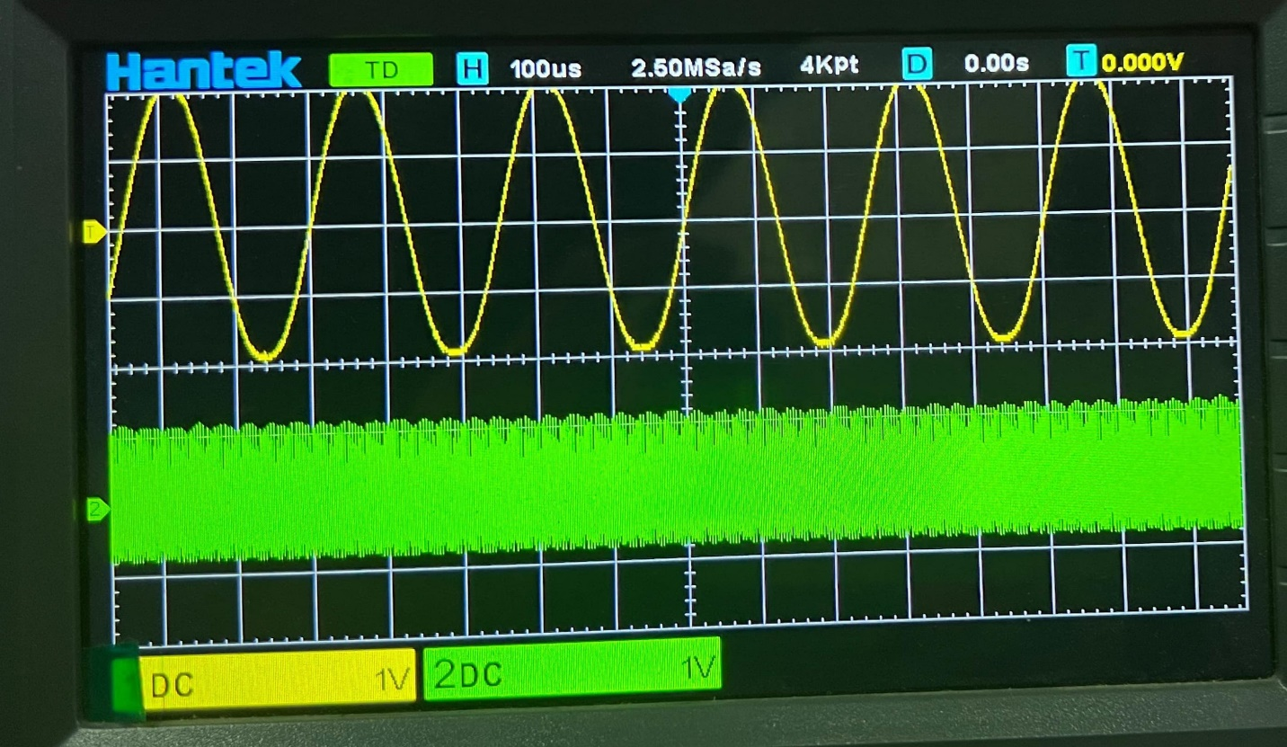

**Questions & Answers :**

1. Why is modulation necessary?  
Ans : Modulation is necessary in communication systems for several reasons:

* It allows the transmission of a signal over long distances without loss of data.
* It enables the multiplexing of signals, i.e., sending multiple signals simultaneously over a single channel.
* It adjusts the signal to match the medium’s properties, such as broadcasting a radio signal.
* It also helps in reducing the interference and noise in the communication system.

2. Why should the carrier waveform be a sinusoidal waveform?

Ans : The carrier waveform is sinusoidal because it’s continuous, differentiable, orthogonal at different frequencies, and energy efficient, making it ideal for transmitting information in communication systems.

3.Write down the mathematical formula for generating a DSB-SC wave.

Ans : Let's say the message signal is denoted by 𝑚(𝑡)*m*(*t*) and the carrier signal is denoted by 𝑐(𝑡)*c*(*t*).

The DSB-SC wave can be expressed as:

𝑠(𝑡)=𝑚(𝑡)⋅cos⁡(2𝜋𝑓𝑐𝑡)*s*(*t*)=*m*(*t*)⋅cos(2*πfc*​*t*)

Where:

* 𝑠(𝑡)*s*(*t*) is the DSB-SC wave.
* 𝑚(𝑡)*m*(*t*) is the message signal.
* 𝑓𝑐*fc*​ is the carrier frequency.
* cos⁡(2𝜋𝑓𝑐𝑡)cos(2*πfc*​*t*) represents the carrier wave.

This formula represents the modulation of the message signal onto the carrier signal, resulting in a DSB-SC wave.

4.What are Sideband ?

Ans : In communication engineering, sidebands refer to the frequency components that result from the process of modulation. When a message signal is modulated onto a carrier signal, it generates sidebands at frequencies above and below the carrier frequency. These sidebands contain the information from the message signal and are crucial for transmitting and receiving the information effectively. There are different types of sidebands depending on the modulation technique used, such as Double-Sideband (DSB), Single-Sideband (SSB), Upper Sideband (USB), and Lower Sideband (LSB). Sidebands play a fundamental role in various communication systems, including amplitude modulation (AM), frequency modulation (FM), and phase modulation (PM).

5.What are the differences between DSB-SC and DSB-WC modulation? Which one is wasteful of transmitted power?

Ans : The main difference between DSB-SC (Double Sideband Suppressed Carrier) and DSB-WC (Double Sideband with Carrier) modulation lies in the presence or absence of the carrier signal.

* DSB-SC: Only the sidebands are transmitted, and the carrier is suppressed.
* DSB-WC: Both sidebands and the carrier are transmitted.

DSB-WC modulation is wasteful of transmitted power because it includes the carrier signal, which does not carry any information but still consumes power during transmission. DSB-SC modulation, on the other hand, eliminates the carrier, thereby conserving power.

**Discussion :**

In this experiment, we investigated the generation of Double Sideband Suppressed Carrier (DSB-SC) amplitude modulation, employing a function generator for the message signal, a carrier signal generator, a mixer (modulator), and an oscilloscope for visualization. By modulating the message signal onto the carrier wave while suppressing the carrier itself, we observed the DSB-SC waveform characterized by two sidebands symmetrically positioned around the carrier frequency, with the carrier effectively eliminated. DSB-SC modulation offers efficient bandwidth utilization and power conservation since it transmits only the information-bearing sidebands, thereby minimizing wasted transmitted power. However, coherent demodulation is crucial at the receiver to accurately recover the original message signal, as any phase or frequency deviations can introduce distortion. This experiment provided valuable insights into DSB-SC modulation, essential for designing efficient communication systems optimizing both bandwidth and power utilization while ensuring reliable signal transmission and reception.